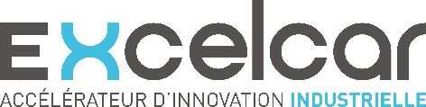
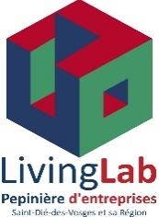
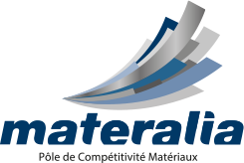
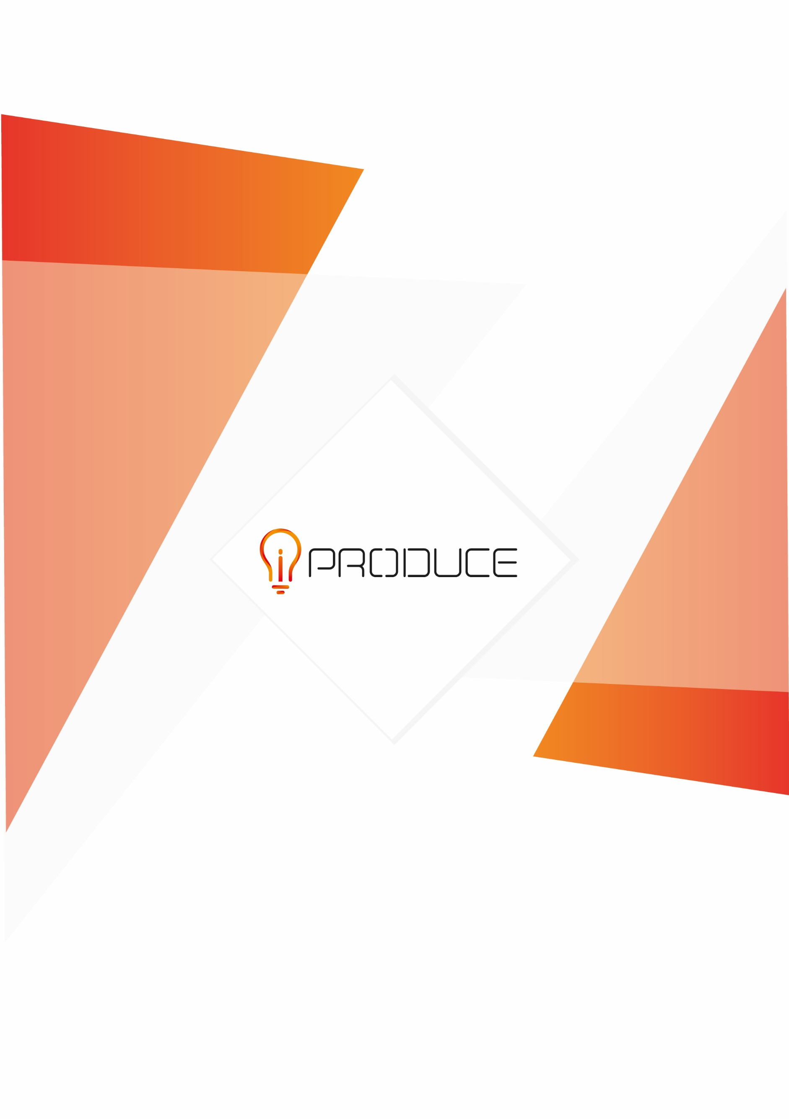
This project has received funding from the European Union’s Horizon 2020 research and innovation programme under Grant Agreement no. 870037.
01 2022
This project has received funding from the European Union’s Horizon 2020 research and innovation programme under Grant Agreement no. 870037
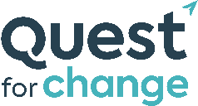
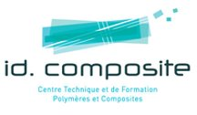
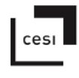
Application File
iPRODUCE competition for open and collaborative innovation | iPRODUCE My Mobility
Materalia – Fablab Vosges – Excelcar – iD4CAR – Quest for Change – CESI – ID COMPOSITE
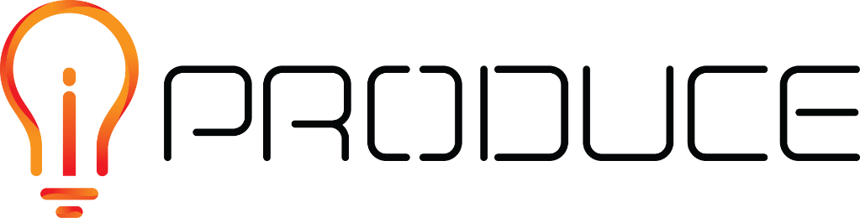
DISCLAIMER

This document contains information and material that is the copyright of iPRODUCE consortium parties and may not be reproduced or copied without consent.

© The information and material included in this document are the responsibility of the authors and do not necessarily reflect the opinion of the European Union. Neither the European Union institutions and bodies nor any person acting on behalf may be held responsible for the use that may be made of the information and material contained herein.
© iPRODUCE Consortium, 2020-2022.
Reproduction is authorized provided the present document and authors are acknowledged

iPRODUCE ● Grant Agreement: 870037 ● Innovation Action ● 2020 – 2022 | Duration: 36 months
Topic: DT-FOF-05-2019: Open Innovation for collaborative production engineering (IA)

Table of contents
1. Introduction 1
1.1. Why participate ? 1
1.2. Is this competition for me ? 1
2. Application 3
2.1. Presentation of the candidate (5% of the final score) 3
2.2. Description of the project and/or product (25% of the final score) 3
2.3. Target market (20% of the final score) 3
2.4. Value and impacts (20% of the final score) 3
2.5. Current status of the project (15% of the final score) 4
2.6. Willingness/motivation to develop the project (15% of the final score) 4
2.7. Stage of development 4
2.8. Contact details of the candidate 5
2.9. Other terms and conditions 5
3. Submission and evaluation 6
3.1. Submission 6
3.2. Evaluation 6
3.3. Announcement of results 6
4. Contact and information 6

Introduction
Within the framework of the European project iPRODUCE, which aims to support project creators and companies in prototyping activities and initial prototype testing, a competition is being organised. This competition will award 3 participants with complete support, including coaching, access to prototyping facilities in an industrial Fablab, test sites and testers.

Why participate ?
The objectives of the competition are:
To help you with “collaborative innovation”: to help you design and test your idea and product with experts in the field and future informed customers, and to provide you with early feedback to better target your innovation and its future market.
The platform iPRODUCE and the network of French partners from the project will support the winners and offer them prototyping equipment and advice from experts and users.
To help you plan the development of your project from the ideation and prototyping phase to a first pre-product, by accompanying you throughout these stages.
Winners will benefit from access to equipment, office space, testing facilities, meeting rooms and coaching. Full-scale tests will also be organised with the winners.
In a few words: don't miss the target, save time, communicate!

Is this competition for me ?
WHO?
The competition is open to any project in the area of mobility, provided that it includes a significant part of physical design involving materials, hardware and manufacturing processes.
The project can be led by a student, an individual, a start-up or a SME, ideally based in France. They must be of legal age (over 18 years old) if they are a student or an individual.
WHAT?
Submissions to the competition must be mobility projects (electromobility, micro-mobility, soft mobility, or related products), involving the development of a physical part or product. Software development activities are not excluded but can only represent a limited part of the project.
The submitted project must be aimed primarily at the general public. It may cover all or only a part of the full project.
The level of maturity of the project must be between the idea and the experimentation of the prototype, the project must be in the development phase. The phases that can be supported through this competition are: ideation, structuring, design, prototyping, experimentation.
The project must be scheduled to start between April and May 2022. The support provided by the French partners in the framework of the competition will end on 31st December 2022 at the latest.

WHY?
In the framework of the competition, the winning candidates will get several rewards:
- 1 year of iD4CAR membership or 1 year of Materalia membership
- 3 days of project coaching by Quest for Change, covering for example the following topics:
- Day 1: Work on the business opportunity and value proposition; Basis for market & competitive analysis
- Day 2: Business model; Business assumptions
- Day 3: Project industrialisation steps
- Co-design of the digital model with a CAD expert dedicated to your product for 5 days
- Access to the design and prototyping resources of the Excelcar & Fablab Vosges for 3 months
- Training in the use of prototyping facilities within Excelcar & Fablab Vosges
- Financing of consumables and materials dedicated to the prototyping of your product up to 3 k€ per project
- Organization of experimentation sessions (depending on the maturity of the project)
- Invitation to an event during the year dedicated to the incubates of Quest for change (invitation to a trade fair, webinar, ...)

In return, the winning candidates commit to using the support and services in the development of their product from the idea to the testing of the prototype. They also commit to test the iPRODUCE tools, as well as to fill in evaluation and feedback forms.

Application
The items in this section must be completed by the candidate. The application can also be filled-in online via this link (application form in French only).

Presentation of the candidate (5% of the final score)
(200 words maximum - Describe the structure/the candidate by specifying its activity/background, and its link with the project, specify whether it is a natural or legal person)

Description of the project and/or product (25% of the final score)
(500 words maximum + illustrations - Descriptive elements allowing the understanding of the project and the product you are developing. You may include or attach diagrams, illustrations or photos of the product)

Target market (20% of the final score)
(500 words maximum - Specify the target market, and if you can, estimate the size of the market. You can attach graphs, diagrams.)

Value and impacts (20% of the final score)
(500 words maximum - Specify the impacts that you expect from the product if you can. It can be in terms of social impact, but also environmental, economic…It can be for the society or for you as an individual,… Please also specify any elements relating to the disruptive aspect of your project.)

Current status of the project (15% of the final score)
(500 words maximum + illustrations - Specify what is the current level of maturity and progress of the product development. Illustrations of the current status can be added.)

Willingness/motivation to develop the project (15% of the final score)
(500 words maximum – Indicate what activities you want to carry out in the near future as part of the development of your product. Please also provide details of your financing plan if possible.)

Stage of development
(At which stage(s) of development would you like to be supported? You can tick more than one box)
- Project support/structuring
- Design
- Prototyping
- Experimentation
- Training
- Other : …………………………………

Contact details of the candidate
SURNAME / First name:
Email:
Telephone:
Website:
Entity/structure name:

Other terms and conditions
All the below conditions have to be checked and met in order to proceed with your application.

- I confirm that I am of legal age
- I confirm that I agree to participate in the evaluations of iPRODUCE methodologies and tools
- I confirm that I have read the specifications of the competition

Submission and evaluation

Submission
Your application must be duly completed and sent to jeremy.keller@materalia.fr with the subject “iPRODUCE competition | iPRODUCE My Mobility” or it can also be filled-in online via this link (application form in French only) by 25th March 2022 at the latest.
If your application files are too large to be sent by email, please send them as a WeTransfer link (or similar) in your application email.

Evaluation
The evaluation will be based on the different headings and will be expressed as a percentage according to the scale indicated set out above.
It will take into account the details of the description and the perspective of the applicant. It will take as a basis for comparison a project that is ideally beneficial to the community and the individual, both in economic, environmental and societal terms.
The jury is composed of the French iPRODUCE partners (Materalia, Fablab Vosges, Excelcar, iD4CAR, Quest for change,…) and will deliberate on the winners on 31st March 2022.

Announcement of results
Results will be announced on 2nd April 2022 and published on the French partners websites and the iPRODUCE project website. All candidates will be informed via e-mail of their result.

Contact and information
For more information about the competition and how to apply, please contact Jérémy Keller at:

Jérémy KELLER
Innovation Manager
iPRODUCE French Network Referent / iPRODUCE My Mobility Competition

Pôle de compétitivité MATERALIA
4, rue Augustin Fresnel – 57070 Metz
Tél : +33 (0)3 55 00 40 33
jeremy.keller@materalia.fr

